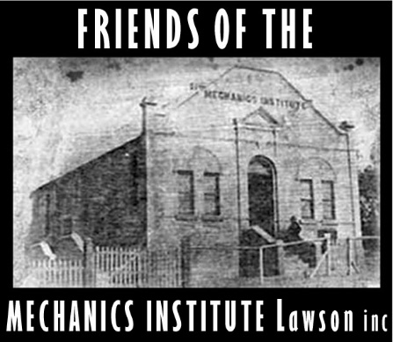
Incorporated (7/5/2014) No.1400644
Associations Incorporation Act 2009
Correspondence:-
PO BOX 130 . Lawson NSW. 2783
Enquiries:-President-John Sheehy- 0403 033 947-sheehy@wix.com.au
APPLICATION FOR RENEWAL of MEMBERSHIP
01/07/2025 to 30/06/2026
(Clause 3 (1)) of the Constitution)

Name

Address

Email address

Telephone

I apply to renew my membership of the incorporated association. I agree to pay the membership renewal fee for the remaining period of 01 July 2026 to 30 June 2027 of $30.00.

PAYMENT OPTIONS-
EFT
Bank Bendigo Bank
Name Friends of the Mechanics Institute Lawson. Inc
BSB 633000
Account 151946779
Ref- Quote your “name- membership” so we can track your payment.

Cash-
Please attend Bendigo Bank branch to deposit your payment into our account.

x__________________________
Signature of renewing member

Date:
NEXT STEP
[Scan the signed form and email to sheehy@wix.com.au or mail to PO Box 130 Lawson. 2783.]

